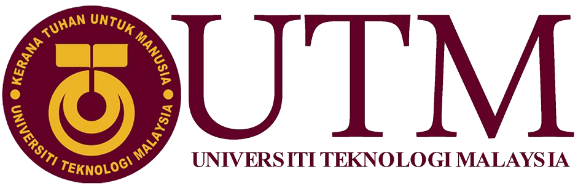

## FACULTY OF COMPUTING SESSION 2023/2024

**COURSE CODE: SECD2613 SECTION: 3**

**LECTURER'S NAME: DR. Rozilawati Binti Dollah**

**Phase2 for Campus Resource Management System**

|  |  |
| --- | --- |
| **Student’s Name** | **Matric No.** |
| Mahmoud Mustafa Elganzory | A23CS0291 |
| Mohamed Omar Makhlouf | A23CS4014 |
| ZHU ZIYI | A23CS4060 |
| Hazza read | A23CS4041 |

# 1.0 Introduction

In the dynamic environment of UTM, the management of campus resources represents a significant operational challenge that impacts the overall efficiency and effectiveness of the educational institution. With the growing student population and the expanding scope of campus activities, it has become increasingly difficult to manage resources optimally using traditional methods. These challenges underscore the need for an innovative and integrated approach to resource management.

The proposed Campus Resource Management System (CRMS) is a digital platform aimed at transforming how resources are managed on campus. By leveraging technology, CRMS seeks to unify various administrative and operational functions into a single, user-friendly system. This system will not only simplify processes but also enhance transparency, accessibility, and

real-time decision-making capabilities.

CRMS will serve as the backbone for managing all campus resources, including academic facilities, administrative offices, recreational areas, and communication channels. The integration of these resources under one platform is expected to lead to better coordination, reduced redundancies, and more effective utilization of the campus's assets. Furthermore, CRMS will play a crucial role in improving the campus environment by ensuring that resources are readily available to students, faculty, and staff, thereby supporting the institution’s mission of providing high-quality education and fostering a vibrant campus community.

# Background study

At UTM, the management of campus resources currently involves a combination of manual processes and disjointed electronic systems. Facilities are booked through separate departmental systems, student information is handled by different administrative offices, and communication between various campus stakeholders often relies on outdated channels. This fragmented approach results in inefficiencies and a lack of cohesion in resource management and communication.

## Existing Systems and Challenges:

1. **Facility Management:**

-Each department runs its own booking system, which often leads to scheduling conflicts and underutilization of resources.

1. **Academic Administration:**

-Enrollments, scheduling, and academic records are handled manually, causing delays and adding to the administrative workload.

1. **Communication:**

-Using various platforms for communication results in information gaps and delays in sharing important updates.

1. **Technological Landscape:**

-Integrated software solutions have proven beneficial in other educational institution

by combining multiple functions into a single platform. These systems have enhanced

operational efficiency, resource use, and satisfaction among user

### Case Studies:

All the faculties: Implemented a unified resource management system that resulted in a 30% increase in facility utilization and a significant reduction in scheduling conflicts.

Faculty of Computing: Introduced a digital academic administration system that decreased the time spent on administrative tasks by 40% and improved data accuracy.

These examples illustrate the potential benefits of implementing a similar system at UTM. The CRMS aims to capitalize on these advancements by providing a unified, user-friendly platform that covers all aspects of campus resource management.

### Justification for CRMS:

The need for CRMS at UTM is evident from both the internal challenges and the success stories of other institutions. By adopting a centralized, digital approach, the university can expect significant improvements in operational efficiency, resource management, and overall campus communication.

### 2.0 Problem Statement

Despite the advancements in educational technologies, UTM continues to face significant challenges in managing its vast array of resources efficiently. The existing processes, primarily manual and siloed in nature, lead to several critical issues:

1. **Inefficiency in Resource Allocation:** Due to the lack of a centralized resource management system, there is frequent overbooking or underutilization of campus facilities like classrooms, laboratories, and meeting spaces. This results in logistical conflicts and dissatisfaction among users.

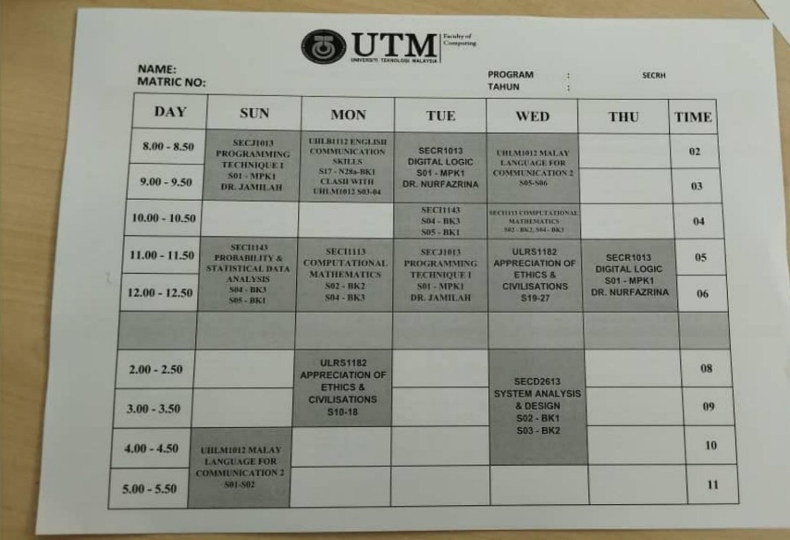

1. **Communication Gaps:** The current decentralized communication channels hinder effective information flow between students, faculty, staff, and administration. Important notifications and updates often do not reach all stakeholders timely, leading to miscommunication and missed opportunities. A notable instance is the issuance of hard copy schedules to

first-semester students, which not only delays updates and corrections but also

poses challenges in accessibility and convenience.

1. **Administrative Burden:** The manual handling of resource bookings, event management, and academic administration consumes considerable staff time and effort, which could be better utilized in more strategic tasks. This also increases the risk of human error and delays in processing requests.
2. **Limited Access to Real-Time Data:** Decision-makers and stakeholders lack real-time access to data regarding resource usage, student performance, and administrative metrics. This impedes their ability to make informed decisions quickly, impacting the overall operational responsiveness of the institution.
3. **Inadequate Support for Strategic Planning:** Without a comprehensive system to analyze and report on the utilization and effectiveness of campus resources, strategic planning is hampered. This limits the institution’s ability to adapt to changing educational demands and to plan for future growth.

The CRMS aims to resolve these issues by introducing a unified platform that not only streamlines resource management but also enhances communication, improves decision-making, and supports strategic administrative planning.

### Objectives

The primary objective of implementing the Campus Resource Management System (CRMS) at UTM is to enhance the management of campus resources through digitization and integration. The specific goals of the CRMS include:

* **Streamline Resource Management:** To create a centralized platform that enables efficient scheduling, management, and utilization of campus facilities such as classrooms, laboratories, auditoriums, and sports fields.
* **Improve Communication:** To establish a robust communication system within CRMS that ensures timely and effective dissemination of information to all campus stakeholders, thereby eliminating existing communication gaps.
* **Reduce Administrative Overhead:** To automate routine administrative tasks related to resource booking, event management, and academic administration, thereby reducing the workload on staff and minimizing human errors.
* **Enhance Decision-Making**: To provide administrators, faculty, and staff with real-time access to critical data about resource utilization, academic performance, and operational metrics, facilitating more informed and quicker decision-making.
* **Support Academic and Operational Planning:** To generate comprehensive reports and analytics that aid in strategic planning and decision-making processes, ensuring that the institution can adapt to future challenges and opportunities efficiently.
* **Digitalize Academic Schedules:** To transition from hard copy schedules to a digital platform, ensuring that all students, particularly those in their first semester, have instant access to accurate and up-to-date scheduling information.

These objectives are designed to address the specific challenges faced by UTM, as identified in the problem statement, and to leverage technology to improve the overall campus experience for students, faculty, and staff.

**3.0 Proposed Solution**

**We can implement several ways to get a better and smooth experience for our users**

**Such as:**

**Improved Communication Channels by setting up better ways for students, faculty, and staff to receive important updates and notifications quickly This will make sure everyone stays informed and reduce miscommunications.**

**Also, creating a single system to handle the scheduling, use, and management of all campus facilities. This will fix the problems and conflicts caused by our current scattered and manual methods.**

**Automate app Tasks:**

**Using automation to handle things like booking rooms, managing events, and scheduling classes. This will lighten the load on staff, reduce errors, and free up time for more important tasks.**

**Including tools for detailed reporting and analysis to help with strategic planning.**

**This will help the university adapt to changing needs and use resources more effectively.**

**Gathering Requirements and Involving Stakeholders:**

**Conducting surveys and interviews with students, faculty, and staff to understand their needs and preferences. Keep everyone involved throughout the development and implementation process.**

**Designing the system interface to be friendly as possible and easy to use with the capability to grow according to the university needs.**

**Also Providing thorough training for everyone who will use the new system.**

**Digital Academic Schedules:**

**Moving from paper schedules to digital ones, so students can always access the latest information. This will be especially helpful for new students.**

**4.0 Information Gathering Process**

**Design of Survey and Spread for CRMS**

**Objective:**

**The survey aimed to gather feedback and ideas from the UTM community on current practices of campus resource management, its efficiency, challenges, and possible enhancements.**

**4.2 Development of Survey:**

**A structured survey was created with 12 questions to collect both quantitative and qualitative data. The questions focused on key aspects of campus resource management:**

1. Familiarity with Existing Practices:

**- How familiar are you with the current practices of campus resource management?**

1. Effectiveness of Current System:

**- How effective do you find the current system for managing campus resources?**

3) Challenges Faced:

**- What challenges do you face with the current resource management system?**

4) Primary Struggles:

**- What is the primary struggles you encounter with the existing system?**

5) Impact of Mistakes:

**- How do mistakes in resource management affect your daily activities?**

6) Consequences of Resource Shortages or Excesses:

**- What are the consequences of running out of or having excess resources on your schedules or activities?**

7) Suggested Solutions:

**- What solutions would you suggest to address the challenges in resource management?**

8) Preference for Automated Features:

**- How would you feel about the introduction of automated booking and real-time updates?**

9) Training and Support Needs:

**- What type of training and support would help you use a new resource management system more effectively?**

10) Notification Preferences:

**- How would you prefer to receive notifications from the resource management system?**

**4.1 Method of Distribution:**

**The survey was distributed electronically using social media to at least 50 participants at UTM, Students were chosen to represent a diverse range of functions and interactions with campus resources.**

**Also, an online survey platform was used for easy access and submission of responses.**

**Collection and Analysis of Data**

**Collection of Responses:**

**- The survey was open for two weeks.**

**- Reminders were sent out periodically to encourage participation.**

**- The online platform automatically collected and organized responses.**

**Analysis of Quantitative Data:**

**- Responses to multiple-choice questions were analyzed to identify trends and patterns.**

**- Percentages were calculated to determine familiarity with current practices, perceived effectiveness of the system, and frequency of challenges faced.**

**Analysis of Qualitative Data:**

**- Responses to open-ended questions were analyzed to identify common themes and specific issues.**

**- Content analysis techniques were used to categorize primary challenges, the impact of inaccuracies, and the potential benefits of suggested solutions.**

**This structured approach to survey development, distribution, and data analysis aimed to provide a comprehensive understanding of the current campus resource management practices and gather actionable insights for future improvements.**

**Here is an interview we conducted with two students to get different perspectives**

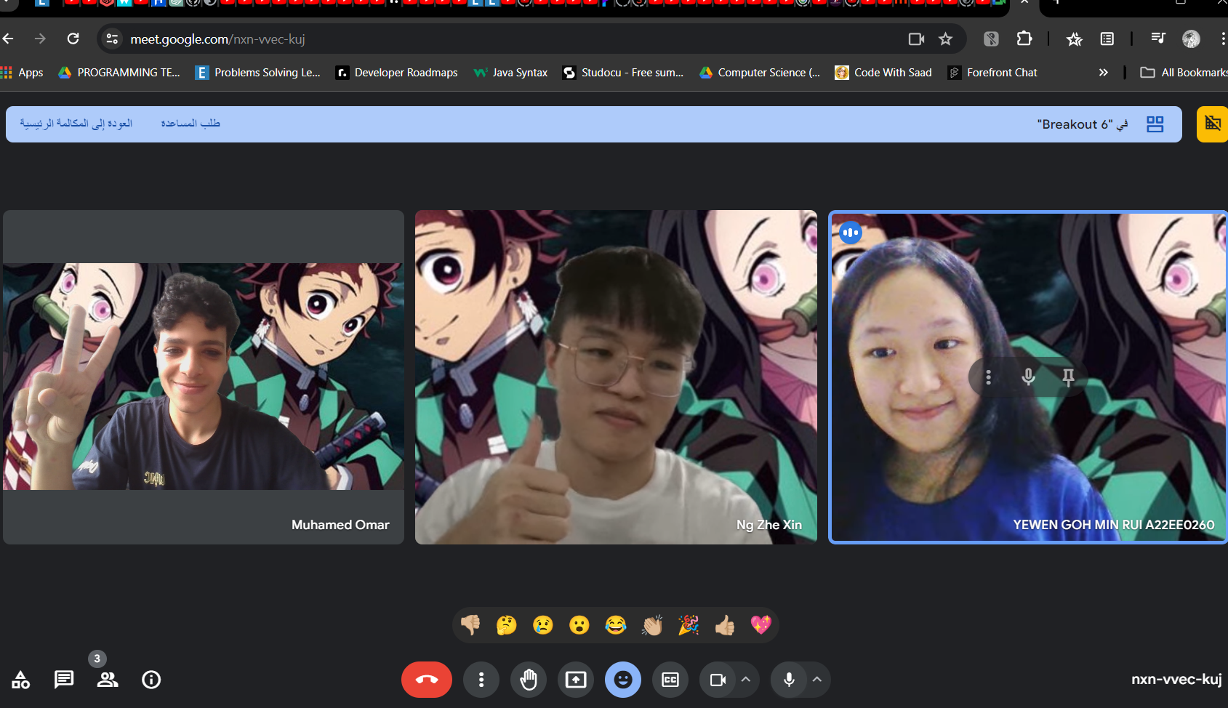**we merged the response with our data representation**

**SURVEY RESPONSE**

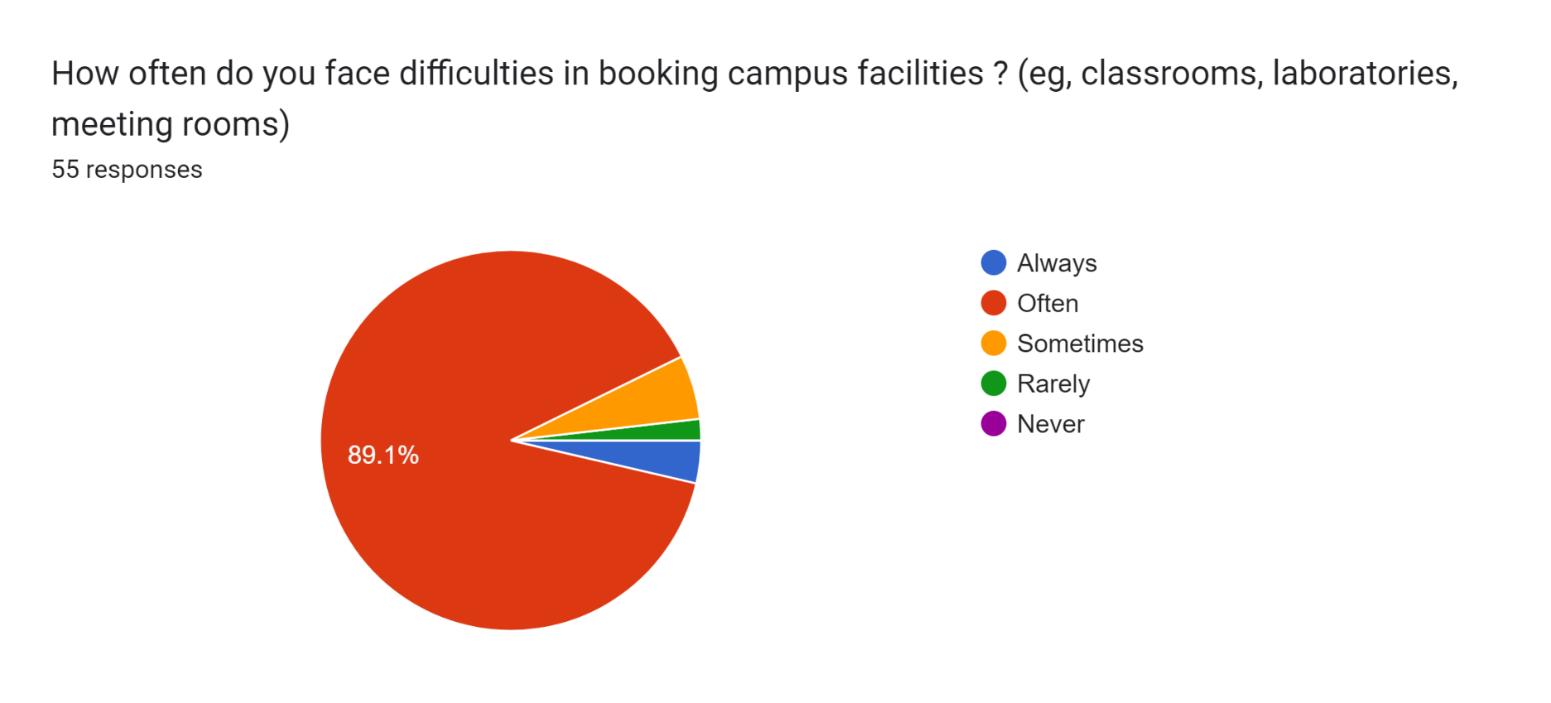

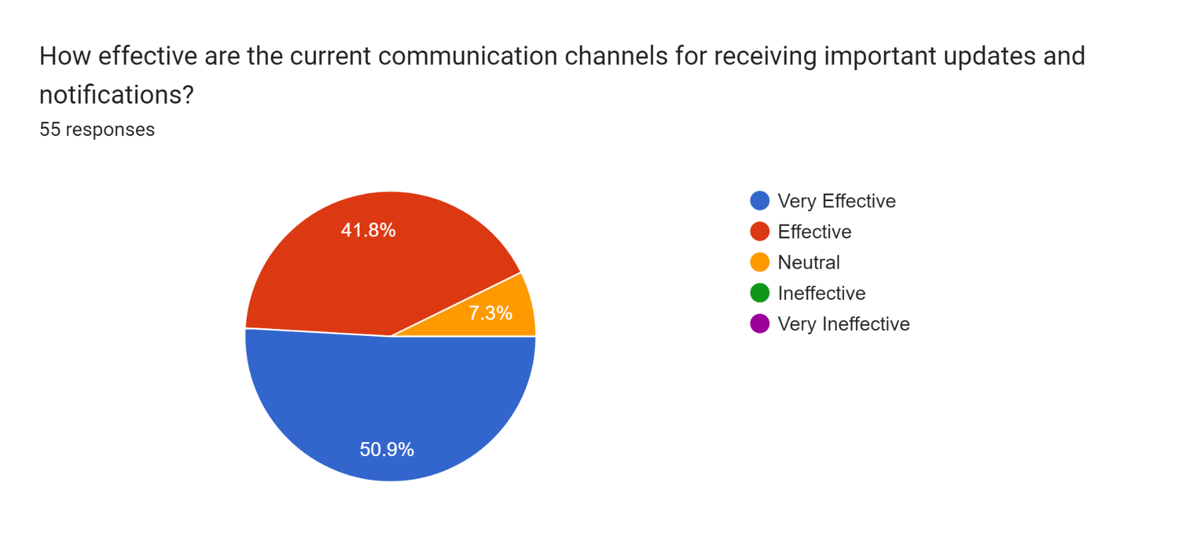

**Forms response chart. Question title: How satisfied are you with the current system used for managing campus resources?
. Number of responses: 55 responses.**

**Forms response chart. Question title: How easy is it to use the current resource management system?
. Number of responses: 55 responses.**

**Forms response chart. Question title: Do you have access to real-time information on resource availability and usage?
. Number of responses: 55 responses.**

**Forms response chart. Question title: What features would you find useful in a new resource management system? (Select all that apply)
. Number of responses: 55 responses.**

**Forms response chart. Question title: What are the main problems you experience with the current resource management system? (Select all that apply)
. Number of responses: 55 responses.**

**Forms response chart. Question title: What would be your top suggestion for improving the current resource management system? (Select one)
. Number of responses: 54 responses.**

**Forms response chart. Question title: How much do the current resource management challenges impact your daily work?
. Number of responses: 55 responses.**

**Forms response chart. Question title: Overall, how satisfied are you with how campus resources are currently managed at UTM?
. Number of responses: 55 responses.**

|  |  |
| --- | --- |
| Scenarios  5.1 | About CRMS. The Campus Resource Management System (CRMS) is a unified digital platform intended to enhance the efficiency of campus resource management, improve communication, and streamline administrative tasks at UTM. This system aims to optimize resource utilization and facilitate real-time decision-making by integrating various functions into an easy-to-use interface |
| Workflow  5.1 | When student send a booking request to the CRMS system, it will inform the administrators, and send the schedule to the faculty. After Faculty back the Enrollment forms and the administrators back the Notifications to the CRMS system. The student can get the Confirmations from CRMS system. |
| Input  5.2 | 1. Local Students 2. Staffs 3. International students |
| Process  5.2 | 1. Manage student requests 2. Handle enrollments 3. Disseminate communications |
| Output  5.2 | 1. Schedules to faculty 2. Notifications to administrators 3. Confirmations to students |
| Performance  5.3 | 1. The system must be secure. 2. The system must be easily accessible and simple. 3. The system must be clear that everyone can get the information’s easily enough. |
| Control  5.3 | 1. Target user groups include UTM student, staffs, and outsiders from Taman Universiti.   2. UTM student may sign up a new account easily by using their matric number.  3. UTM staffs may sign up a new account easily by using their staff identification number. |

**5.4 THE (AS-IS) DFD Drawings:**

**1-Context Diagram**

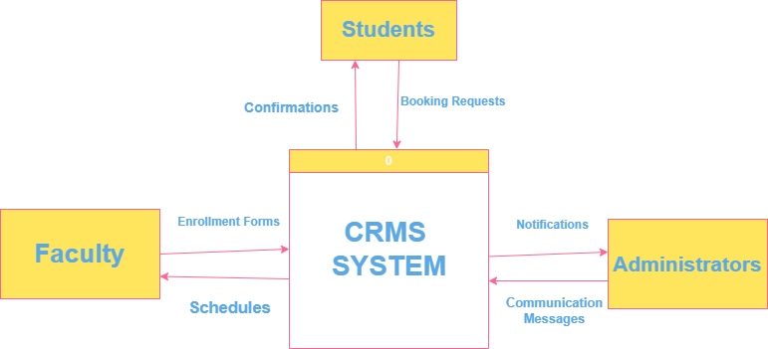

**2-Diagram Level 0**

**3- Child Diagram**

**6.0 Summary of requirement Analysis process**

**In the Requirement Analysis Process for our Campus Resource Management System (CRMS), we utilized a variety of data collection methods, including surveys and interviews, to deeply engage with stakeholders. This approach allowed us to thoroughly understand the current (AS-IS) state and gather detailed user requirements. Through our analysis, we identified significant inefficiencies and functional gaps in the existing resource management systems, which guided us in pinpointing both functional and non-functional requirements.**

**Stakeholder feedback was particularly insightful, highlighting the need for improved communication and more streamlined administrative processes. These insights were consistent with the challenges we observed and helped shape our proposed solutions. This comprehensive analysis not only confirmed the necessity for an integrated digital platform but also informed the core objectives for developing the CRMS. Our goal is to ensure that the future (TO-BE) system addresses these critical needs in a comprehensive and effective manner.**